Issues with setting soil properties that are consistent with SoilTemperature’s expectations.

**No Clay% data:**

* Clay% is used in the pedotransfer functions to estimate the soil thermal properties – it is a required input
* Many soils in APSoil and the test suit do not have this value entered in the soil descriptions

*Solution:*

* If no Clay% data is supplied then assume the Clay% is 30% at all depths
* Insert this into the GUI, highlighting that it is an APSIM assumed value, encourage users to input more accurate data but allow the simulation to proceed as is
* User can then type over the supplied values in the GUI if they have better information – and in this case the highlighting would go away

**No Rocks% data:**

* Rocks% appears to not be pulled through from APSoil (if it even exists in that database)
* Most soils will, in reality, have a value of 0 (no rocks) but there are substantial areas of stony/rocky soil in New Zealand and internationally
* APSIM does not currently handle these very well
* The Rocks% is important for calculating the thermal properties

*Solution:*

* If Rocks% is non-blank (0 is a valid entry) then assume those values
* If Rocks% is blank then estimate the value by layer:
  + Assume rp (particle density) is 2.65 Mg /m3
  + Estimate effective total porosity (tp) as (1-bd/rp)*0.93
  + If (1-Sat/tp) > 0.1 then take RocksFraction = (1-Sat/tp), else 0.0
* This has been tested on a range of soils and is giving sensible starting points. Below is a plot of measured and estimated Rocks% for one soil (note that this soil has no rocks in the top three layers)
* As with Clay%, show the estimated values with some highlight in the GUI and alert users to overwrite if needed

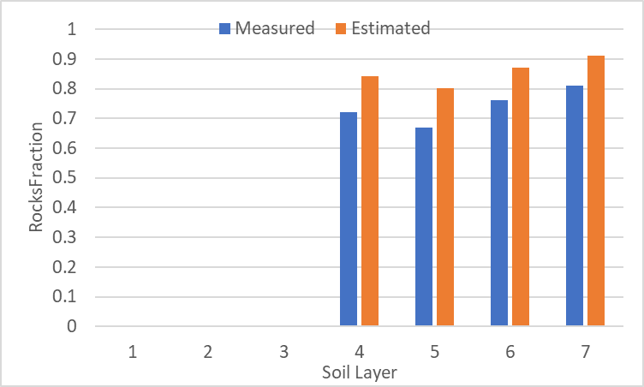

**Soil properties are structured for the fine-earth fraction but are expected to be whole-soil values**

* Soil properties in APSIM as functionally for the fine-earth fraction but the thermal properties are a function of the whole-soil.

*Solution*

* Within SoilTemperature convert the Clay%, BD and Carbon% to whole soil values before calculating the thermal properties
* This will have no effect on other models in APSIM
* Estimate whole-soil values as:
  + BD_whole = BD+Rocks%/100*2.65
  + Clay_whole = (100-Rocks%)*Clay%/100
  + OM_whole = (100-Rock%)*OM%/100
* Use the above parameters to calculate the thermal conductivity parameters (L713)

|  |  |  |  |  |  |  |  |  |  |
| --- | --- | --- | --- | --- | --- | --- | --- | --- | --- |
| As in the GUI | | | | | |  | Whole-soil values | | |
| Depth | Clay | Rocks | BD | Sat | Carbon% |  | BD | Clay | OM |
| 0-170 | 22 | 0 | 1.2 | 0.498 | 2.9 |  | 1.2 | 22 | 2.9 |
| 170-280 | 23 | 0 | 1.35 | 0.458 | 1.2 |  | 1.35 | 23 | 1.2 |
| 280-360 | 22 | 0 | 1.42 | 0.439 | 0.67 |  | 1.42 | 22 | 0.67 |
| 360-470 | 24 | 72 | 0.389 | 0.126 | 0.92 |  | 2.297 | 6.72 | 0.2576 |
| 470-700 | 12 | 67 | 0.436 | 0.155 | 0.77 |  | 2.2115 | 3.96 | 0.2541 |
| 700-950 | 5 | 76 | 0.336 | 0.106 | 0.52 |  | 2.35 | 1.2 | 0.1248 |
| 950-1500 | 3 | 81 | 0.295 | 0.074 | 0.42 |  | 2.4415 | 0.57 | 0.0798 |